**Braised Liver**

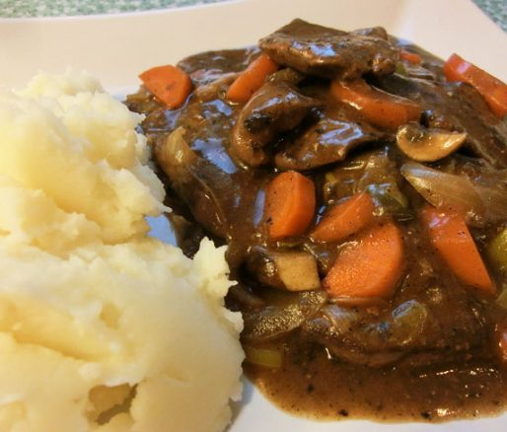

**INGREDIENTS**

1 1/2 pound(s) beef liver semi frozen

1 tablespoon(s) meat seasoning

1 teaspoon(s) salt

1/2 teaspoon(s) black pepper

2 ounce(s) soy sauce

1 tablespoon(s) garlic blended with a little oil

1 ounce(s) vegetable oil

1 large onion cut in rings

1 sprig(s) thyme

2 ounce(s) tomato ketchup

2 ounce(s) water

**METHOD**

1. Strip and slice the chilled liver. Add meat seasoning, salt, black pepper, soy sauce and garlic.
2. Stir to ensure all the seasonings are properly distributed.
3. Cover and place in the refrigerator to marinate for 2 hours.
4. Add oil to a saute pan and heat over high flame; add liver and saute for about 3-5 minutes.
5. Add onions, thyme, tomato ketchup and water, stir, cover and allow to cook for another 3 minutes.
6. Season to liking. May be served with a side of vegetables, mashed potatoes, rice and peas, boiled food or fried dumplings and other breakfast foods.